First, run the server, then, run the client, and the client will make request 100 times, so it will sum up the positive integer from 1 to 100, and print all the sum result back in the client side.

This is the first Screen shot of the client side.

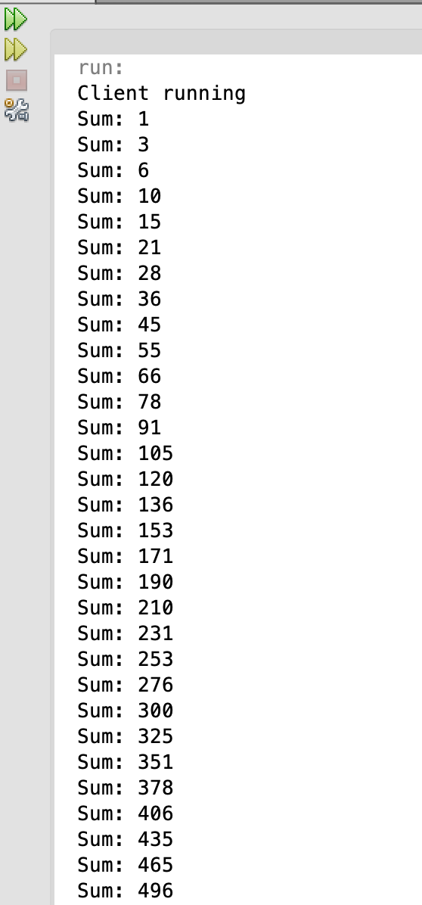

This is the second screen shot from the client side.

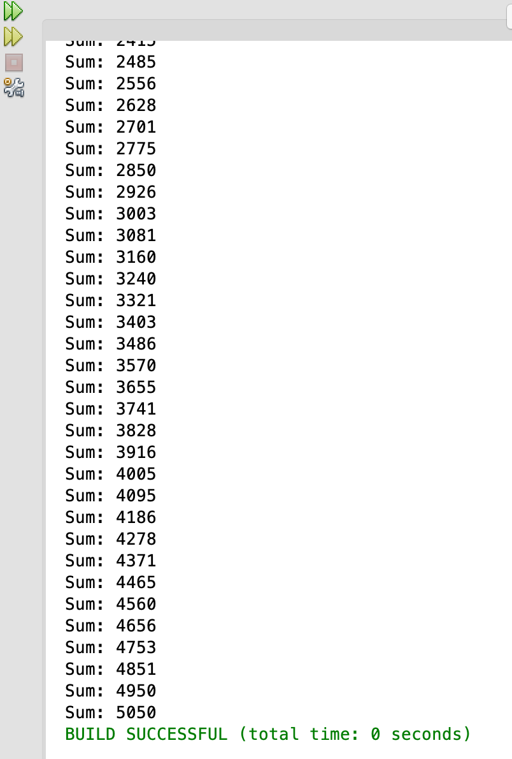

This is the first screen shot from the server side.

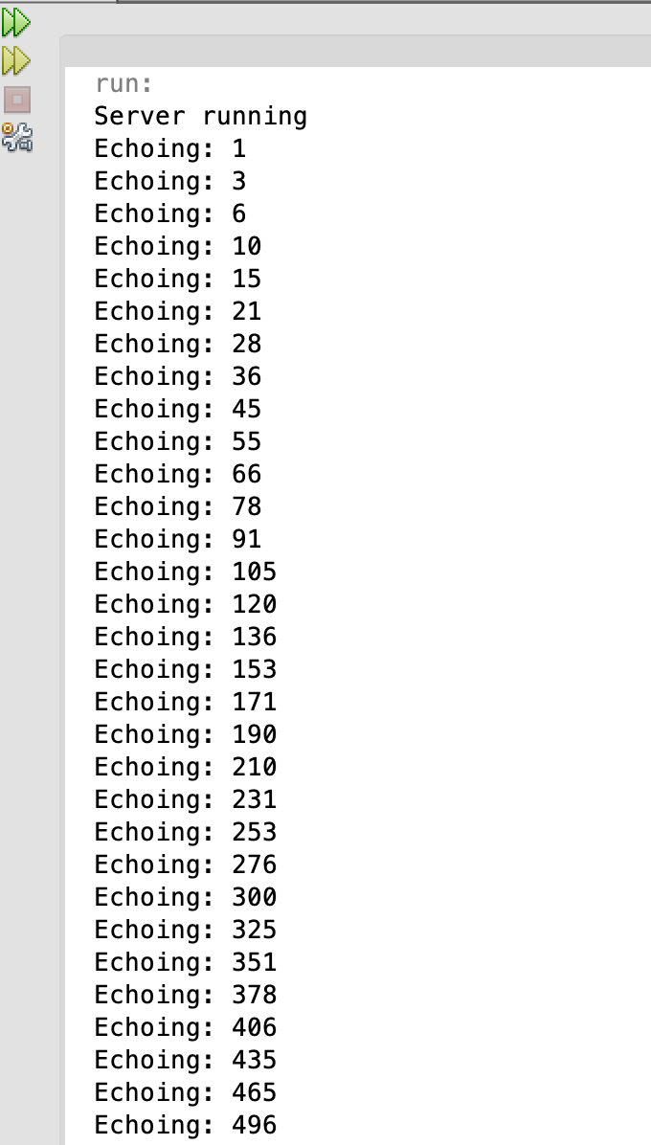

This is the second screen shot from the server side.

